
COLEGIO SECUNDARIO N. º 5070 “MARÍA TERESA CADENA DE HESSLING”

Calle Filiberto Menes 536– 🕿 4384542 - C.P. 4400 - Salta

English Final Exam MARK_________
COURSE : 2º
STUDENT`S NAME : ……………………………………………………. DATE : …………………………………………

Criterios de Acreditación:
- Elaborar oraciones reconociendo las diferentes estructuras gramaticales.
- Formular y responder preguntas aplicando los diferentes tiempos de verbos.
- Comprender textos con carga léxica acorde al nivel.
A-Complete the sentences using verb TO BE. (_/5) B- Order the words to form sentences. (_/5) 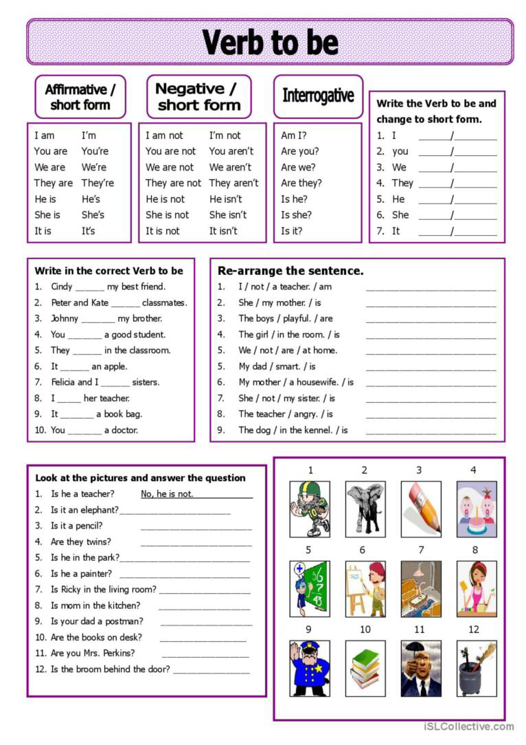
C-Look at the pictures and answer the questions (_/5)
D-Match the questions with the answers. (_/5) E- DEMONSTRATIVE PRONOUNS ( _ /5)
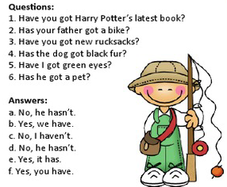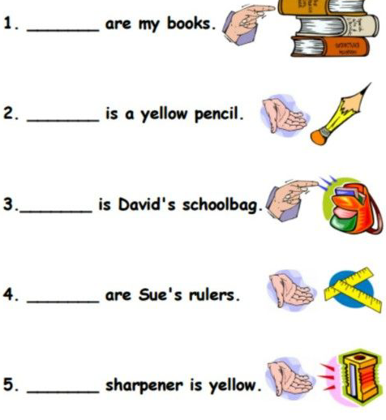
1_C_ 2____ 3_____ 4_____ 5______ 6 ______
F- Write the correct plural form of the words in brackets ( _/10)

I see three _ (woman) in the room.
- My __ (foot) are cold. Where are my socks?
- There are a lot of (mouse) in the garden.
- I like (apple).
S. How many __________ (box) have you got?
- There are ten _________ (child) in our class.
- The______________ (fish) aren't swimming now.
- How many (pen) have you got?
9. There are many(butterfly) flying between the flowers.
10. I have a lot of (dress)
G-Choose the correct option.Then answer the questions ( _ /10)
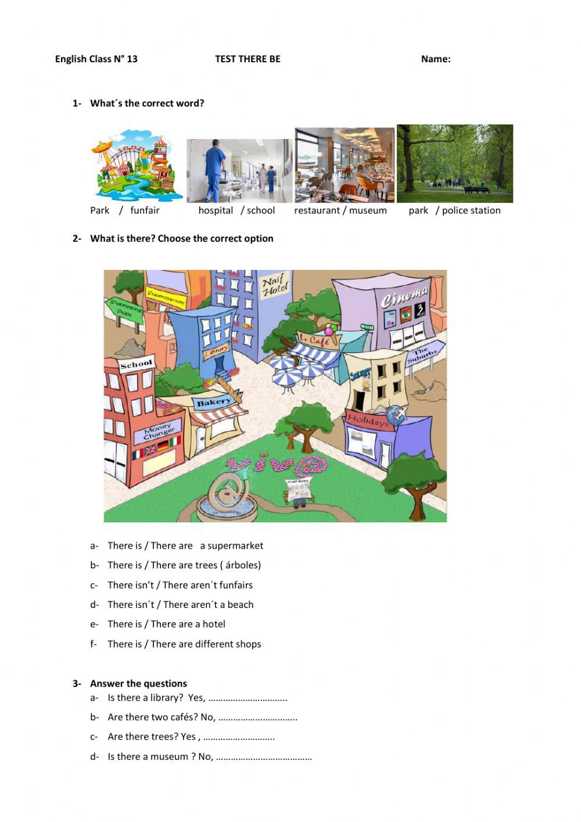
H- Look at the information and write about Lucy ( _ /15)




