
COLEGIO SECUNDARIO N. º 5070 “MARÍA TERESA CADENA DE HESSLING”

Calle Filiberto Menes 536–  4384542 - C.P. 4400 - Salta
5to AÑO
English Exam
Criterios de Acreditación:
- Elaborar oraciones reconociendo las diferentes estructuras gramaticales.
- Formular y responder preguntas aplicando los diferentes tiempos de verbos.
- Comprender textos con carga léxica acorde al nivel.
Actividades:
- ZERO CONDITIONAL: Complete these sentences. (___/ 10)
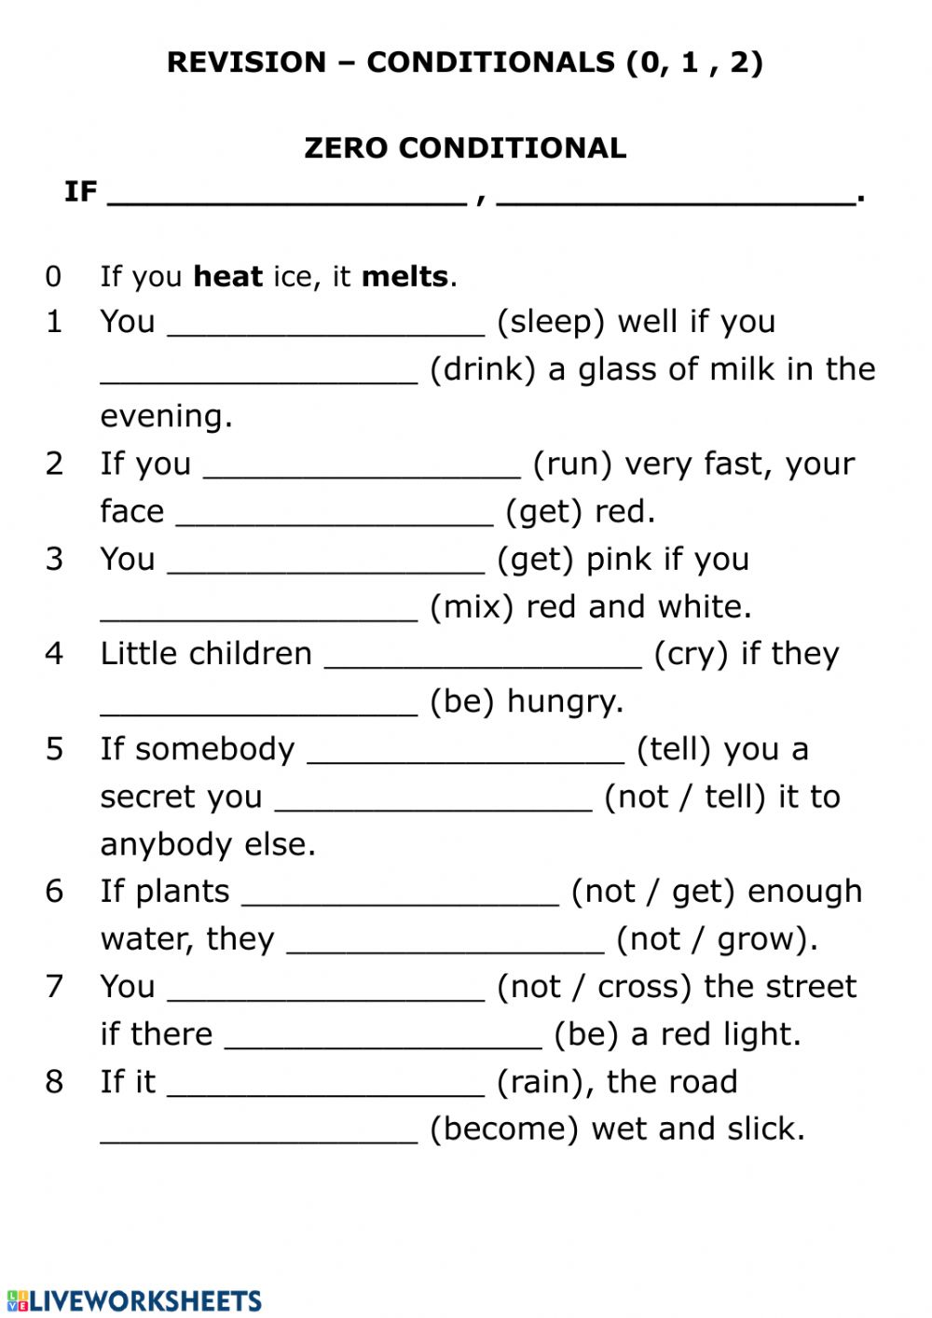
- PRESENT PERFECT TENSE: Write sentences (+, -, ?). (___/ 10)

- We/ watch TV/ all night long. __________________________________________________
- She / not / speak/ French __________________________________________________
- They/ finish/ their homework/? _______________________________________________
- Vicky /pay / the bill _______________________________________________
- Oliver/ not / cook/ dinner ________________________________________________

3.Look at the pictures and write predictions. Use these verbs: HAVE-SKY-RAIN-WASH-FALL.(__/5) 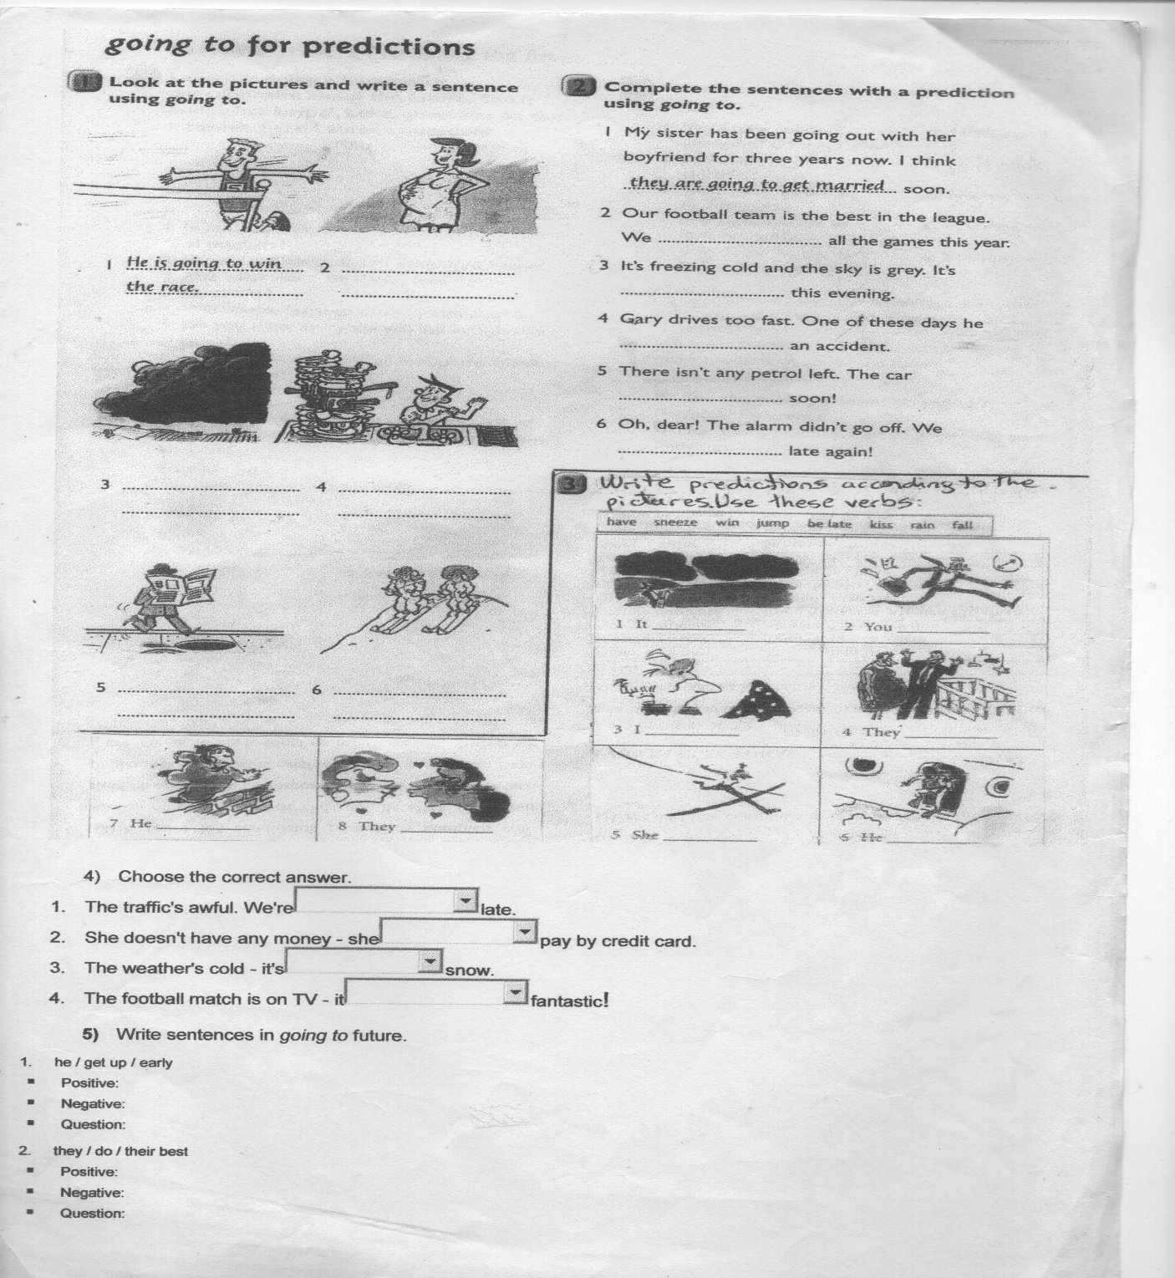
- PASSIVE VOICE: Read the text and complete with the verbs at the bottom. (__ / 12)
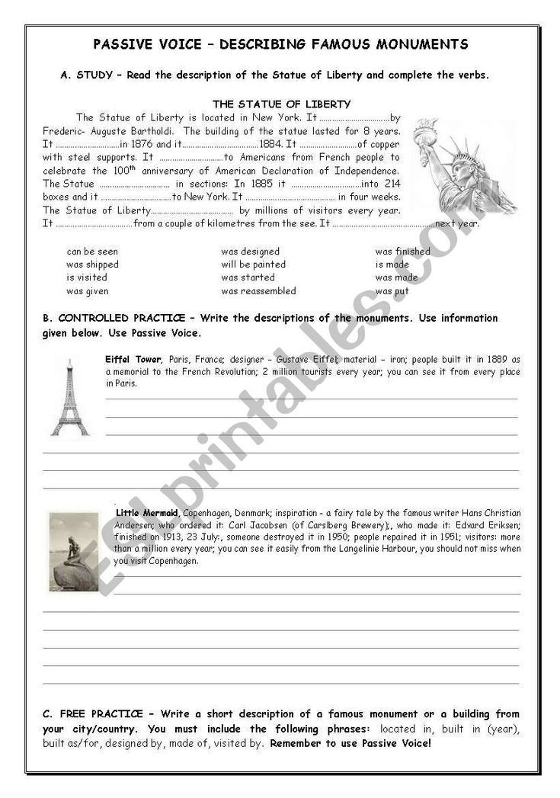

- Answer the questions about the text. (___ / 8)
- Where is the Statue of Liberty located? ____________________________________
- Who designed it? ____________________________________
- When was it started? ______________________________________
- When will it be painted? _______________________________________

- Write a short description of a famous monument or a building from your city/country. You must include the following phrases: located in, built in (year), built as / for, designed by, made of, visited by.
Remember to use Passive voice! (___/ 15)

________________________________________________________________________________
________________________________________________________________________________
________________________________________________________________________________
________________________________________________________________________________
________________________________________________________________________________
_________________________________________________________________________________

GOOD LUCK!!!!!

