Test 1° Year
Colegio María Teresa Cadena de Hessling
Criterios de Evaluación: Elabora oraciones utilizando las estructuras gramaticales y el vocabulario trabajado. Formula preguntas y respuestas aplicando los diferentes tiempos verbales. Comprende textos con carga léxica acorde al nivel.
Task 1: Read and complete with IS, AM, ARE ___/10.

Task 2: Write the questions. ___/10.

- You /a doctor?
___________________________________ 2. They / intelligent?
___________________________________ 3. A nurse/ she?
___________________________________ 4. He / a pilot?
___________________________________ 5. It / your pencil?
___________________________________

- I ______ a student.
- He _______ a photographer
- You _______ my best friend.
- We ________ tal.
- They __________ dentists.
- Mary ________ an artista.
- Paul and José ________ chefs.
- The dog________ small.
- The boys _________ weak.
- She _______ beautiful.

Task 3: Match the questions with the answer____/10.

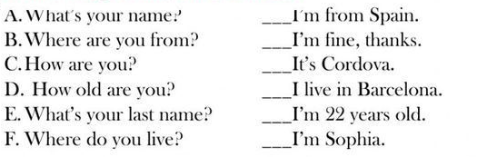
Task 4: Circle the correct option____/5.

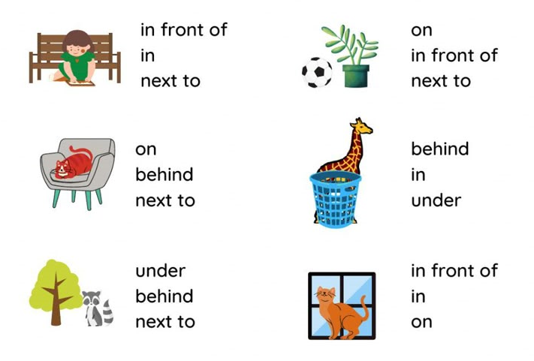
Task 4: Read the text

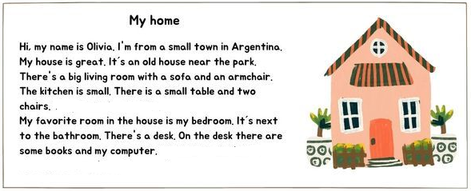
Task 5: Read the text again and answer TRUE or FALSE____/5.

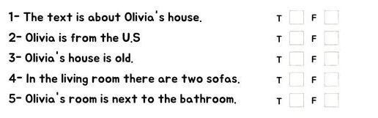
Task 6: Read the text again and answer TRUE or FALSE____/15.

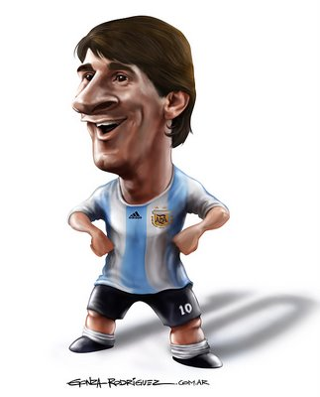
Task 6: Read the text again and answer TRUE or FALSE____/5.

-------------------------------------------------------------------------------------------------------------------------------------------------------------------------------------------------------------------------------------------------------------------------------------------------------------------------------------------------------------------------------------------------------------------------------------------------------------------------------------------------------------------------------------------------------------------------------------------------------------------------------------------------------------------------------------------------------------------------------------------------------------------------------------------------------------------------------------------------------------------------------

WEAK TALL OLD HAPPY FAT THIN


     

